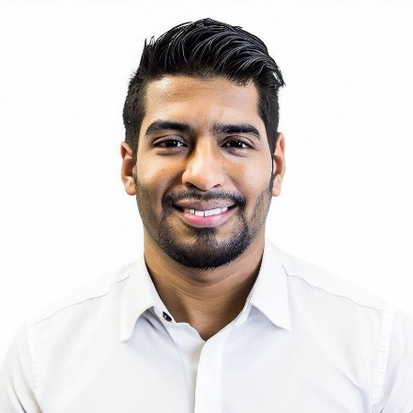





Skills

- Search Engine Optimization (SEO)
- Search Engine Marketing (SEM)
- Social Media Marketing and Advertising
- Content Marketing
- Email Marketing
- Google Analytics and Marketing Analytics
- Marketing Automation
- A/B Testing and Conversion Rate Optimization
- Creative Content Creation
- Branding and Campaign Development

Experience

Jan 2019 – Present
Prime Digital Solutions, New Delhi
Digital Marketing Manager
Orchestrated strategies for 30% traffic growth and 5:1 ROAS through Google Ads and social campaigns. Boosted organic search rankings by 40%.
Jul 2016 - Dec 2018
Innovative Tech Solutions, Gurgaon
Digital Marketing Specialist
Led 50% website traffic increase, managed social channels with 30% growth, and optimized email campaigns with 25% higher open rates.

Profile

Experienced and result-driven Digital Marketer with expertise in SEO, SEM, social media, content, and email marketing. Skilled in data-driven optimizations, creative engagement, and building brand visibility. Committed to staying updated with the latest trends and technologies.

Sanjay Kumar
  - Digital Marketer

Certifications

- Google Ads Certification
- HubSpot Inbound Marketing Certification
- Facebook Blueprint Citification

Education

Bachelor of Business Administration (BBA) in Marketing
Delhi University, New Delhi
2016

Contact

1, Main Street – New Delhi
+91 9876543210
sanjay.kumar@email.com
linkedin.com/sanjy.kumar

